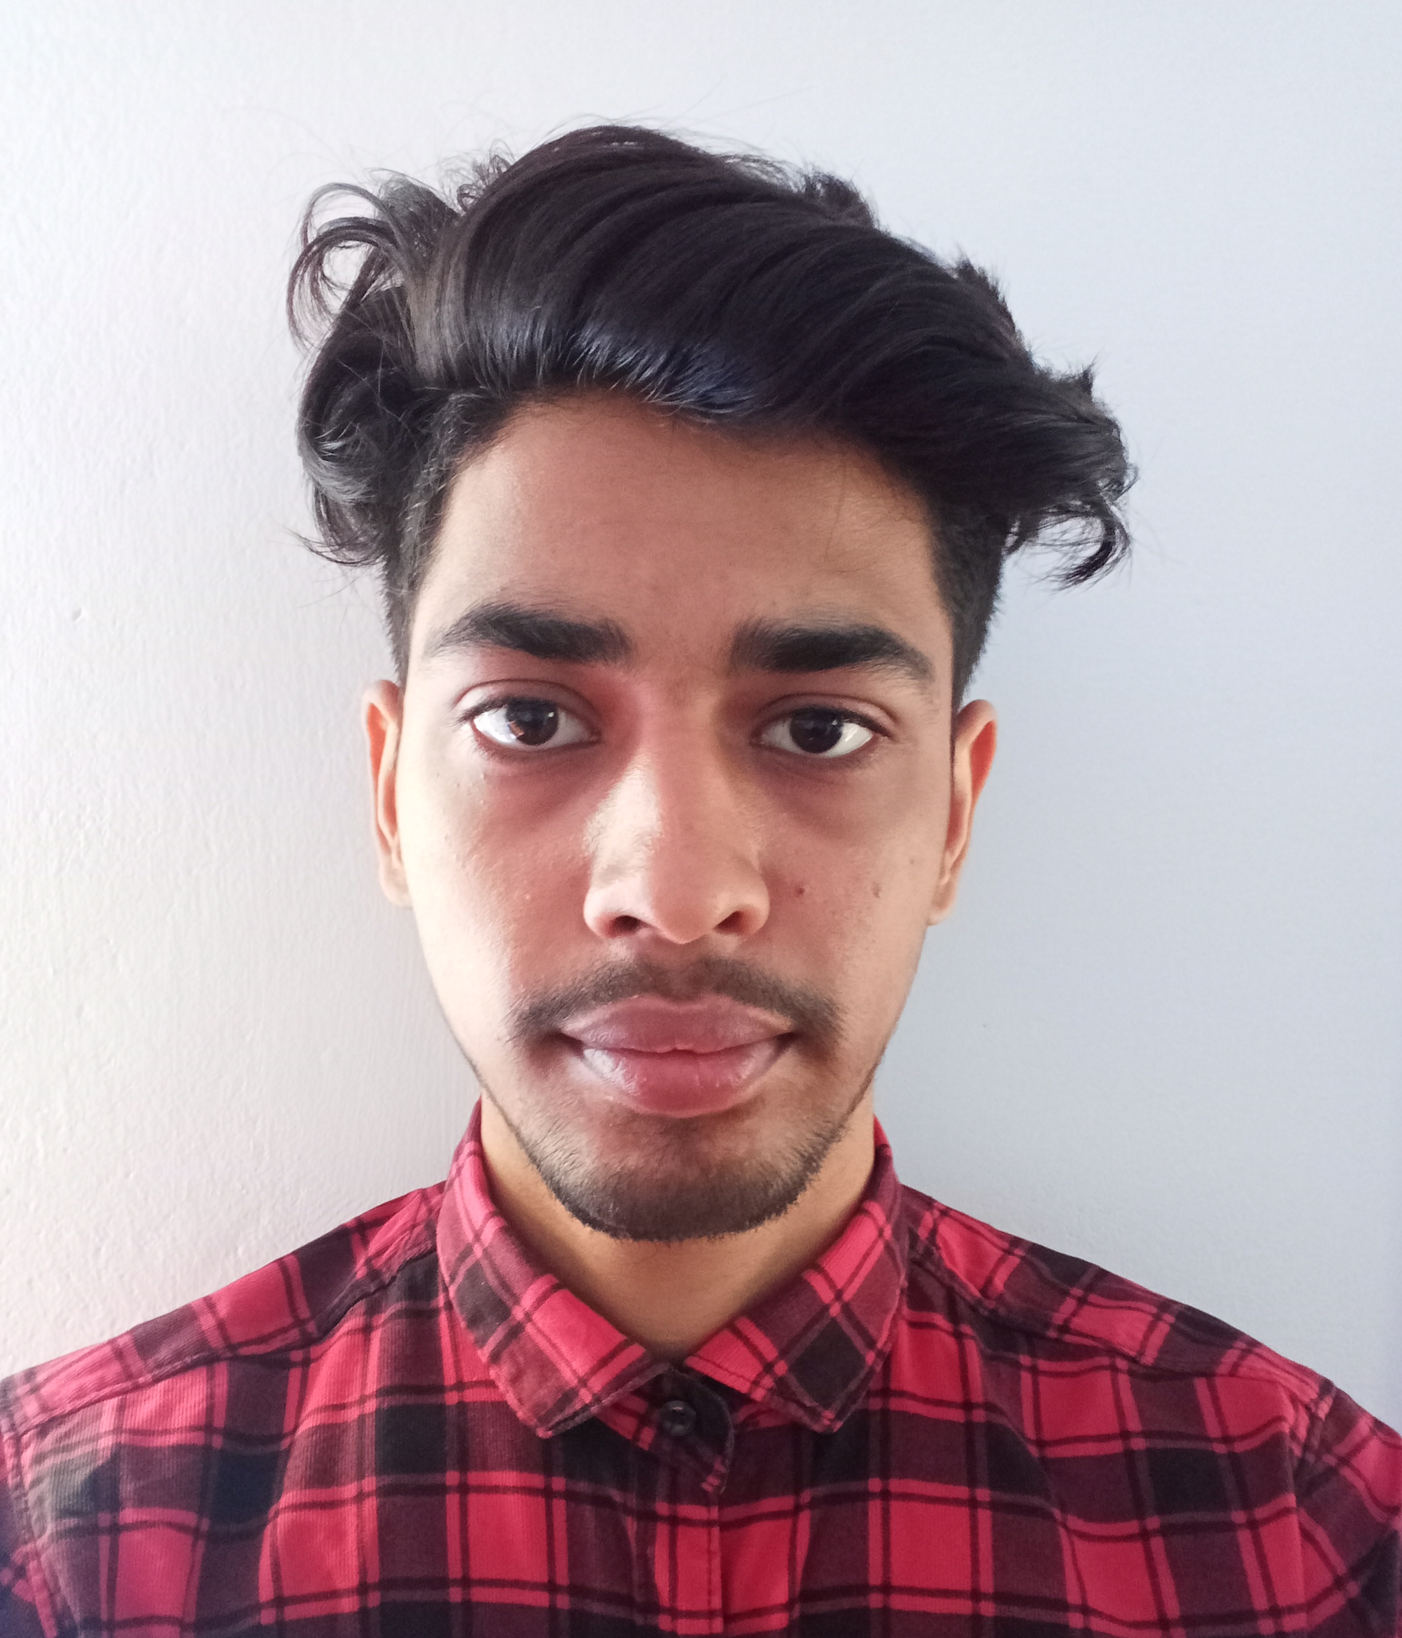
_{ABHISHEK SINGH}

DOB- 30 March, 2001
abhisheksingh81037272@gmail.com | 9365524166
Urrunabond T.E, Silchar, Cachar, Assam -788031

EDUCATION

NORTH EASTERN REGIONAL INSTITUTE OF MANAGEMENT

BCA

JUNE 2023 | CGPA: 7.3

D.N.HS COLLEGE
S
HS | Science | PCM

Jun 2020 | Per: 50%

D.N.HS SCHOOL
HSLC

May 2017 | per: 61.83%

LINKS

Facebook: www.facebook.com/ab.abhishek.1806?mibextid=ZbWKwL
LinkedIn:
abhishek-singh-531889240/
Github:
https://github.com/Abhisheksingh0303

EXPERIENCE
4 MONTH

WEB INFOTECH | INTERNSHIP | JAN 2023 – MAY 2023 | GUWAHATI.

FRONT-END | HTML | CSS | BOOTSTRAP | JAVASCRIPT.

. Created and maintained responsive and visually appealing web pages using HTML, CSS, and
Bootstrap frameworks.

. Assisted in developing and testing website features, functionalities, and user interfaces.

. Debugged and fixed website issues to ensure optimal user experience and functionality.

BACK-END | PHP | LARAVEL | MY SQL.

. Developed and maintained dynamic web applications using PHP and Laravel frameworks.

. Integrated front-end templates with back-end functionalities to create seamless user experiences.

. Implemented best practices in software development, including code documentation, testing, and
optimization.

PROJECTS

SKILLS

PROGRAMMING

Languages

• Intermediate | C++, PHP
• Novice | JavaScript

Tools
• Git • Windows

Framework & Library
• Laravel

Technologies
• HTML • CSS • SQL

OTHERS
• Problem Solving
• Communication
• Leadership
• Quick Learner

SALON MANAGEMENT SYSTEM
TECHNOLOGY | HTML | CSS | JAVASCRIPT | PHP | MY SQL.
Link | https://github.com/Abhisheksingh0303/Salon-Management-System

. Salon management software helps businesses operate more efficiently and purpose of salon
management software is to streamline salon operations
. Admin can manage customer and employee details, track inventory, generate sales reports,
Invoice Report etc.

. Users can book appointments, view offered services, and subscribe to the page.

COFFEE SHOP WEBSITE
TECHNOLOGY | HTML | CSS | JAVASCRIPT | PHP | MY SQL.
Link | https://github.com/Abhisheksingh0303/cafe-project

. provides the admin with access to manage all data.
. Less prone to errors and reduce manual records.
. The system is user friendly.
. Minimize the manual work and maximize the productivity.

ACHIVEMENTS
SPORTS
• GOLD MEDAL Cricket League.
• GOLD CUP Badminton Tournament.

